CPU Scheduling Requirement Analysis


BY

Areeba Talib
(Reg. No. 2023-UOK-05)
&
Maham Gulzar
(Reg. No. 2023-UOK-10)
&
Aliya Shoukat
(Reg. No. 2023-UOK-39)

Session 2023-2027

University of Kotli Azad Jammu and Kashmir
Faculty of Computing & Engineering
Department of CS&IT


Submitted To
Sir Mehtab Mushtaq

Submitted by
NAME: AREEBA ,MAHAM,ALIYA
CLASS: BS (IT) 5th
ROLL NO: 05, 10, 39
SUBJECT: OPERATING SYSTEM
SESSION 2023-2027

Submission Date: 20th Feb 2026

University of Kotli Azad Jammu and Kashmir
Faculty of Computing & Engineering
Department of CS&IT
Table of Contents

DIAGRAM 1
1 EVOLUTION OF OPERATING SYSTEM 1
1.1 User Interface (UI) – Presentation Layer 1
1.2 User Input Handler 1
1.3 Validation & Error Handler 2
1.4 Error Messages 2
1.5 Scheduling Engine – Business Logic Layer 2
1.6 Algorithm Selector 2
1.7 Time Calculator 2
1.8 Database (Process DB) 2
1.9 Output Generator – Reports & Output Layer 3
1.10 Gantt Chart / Results 3
1.11 Reports 3
1.12 Performance Monitor – Monitoring Layer 3
2. Requirement Analysis 3
2.1 Functional Requirements 3
2.2 Non-Functional Requirements 4
3. Explanation of CPU Scheduling System Component Diagram 4
3.1 How to create this diagram? 4
4. Conclusion 5

DIAGRAM
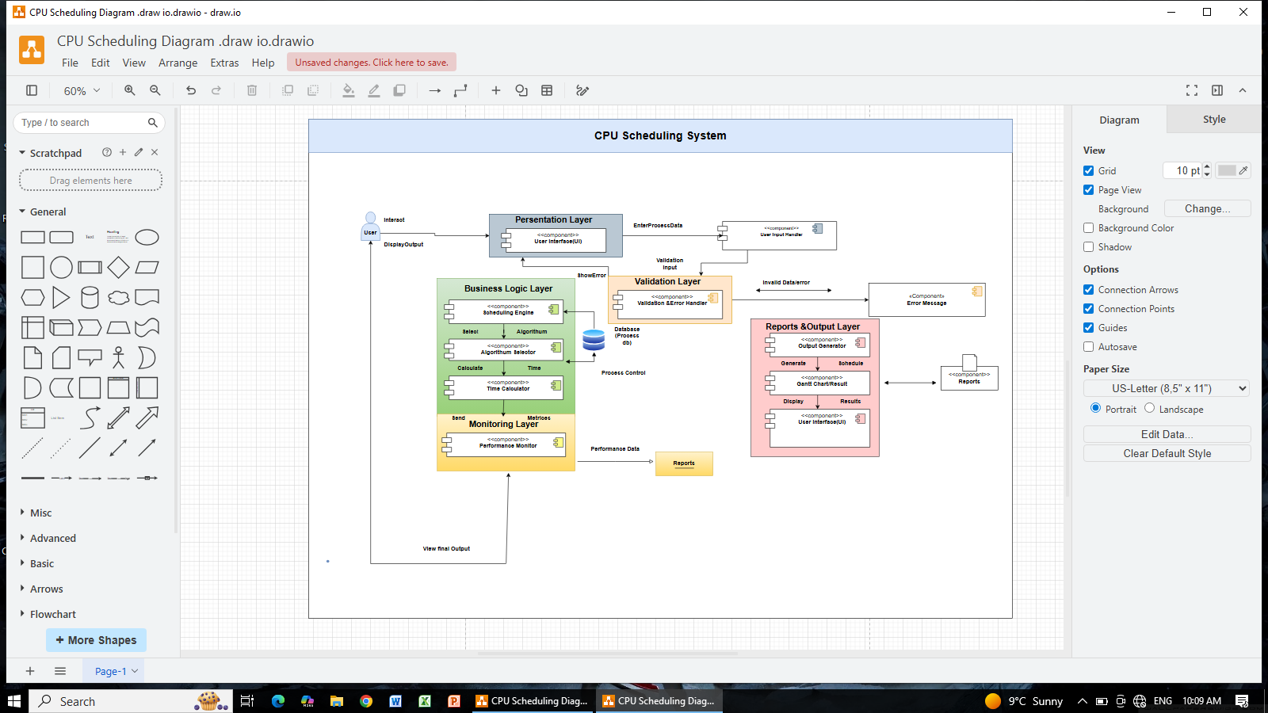

1 EVOLUTION OF OPERATING SYSTEM

1.1 User Interface (UI) – Presentation Layer
- This is the front part of the system where the user interacts.
- The user enters process details like arrival time and burst time.
- It displays results and error messages on the screen.
- It acts as a bridge between the user and the system .

1.2 User Input Handler
- It receives data entered by the user.
- It converts the input into a proper system format.
- It sends the input to the validation layer.
- It helps manage user input efficiently.

1.3 Validation & Error Handler
- It checks whether the input data is correct or not.
- It verifies values like arrival time and burst time.
- It rejects invalid or missing data.
- It forwards valid data to the next layer.

1.4 Error Messages
- It shows messages when input is incorrect.
- It informs the user about what went wrong.
- It displays clear and simple error notifications.
- It helps the user correct mistakes.

1.5 Scheduling Engine – Business Logic Layer
- It is the main core of the system.
- It manages the CPU scheduling process.
- It arranges processes based on the selected algorithm.
- It works with other components to produce results.

1.6 Algorithm Selector
- It selects the scheduling algorithm to use.
- It can choose FCFS, SJF, or Round Robin.
- It works according to the user’s selection.
- It sends the chosen algorithm to the scheduling engine.

1.7 Time Calculator
- It calculates waiting time for each process.
- It calculates turnaround time.
- It computes average waiting and turnaround time.
- It sends calculated results to the output layer.

Database (Process DB)
- It stores all process information.
- It saves arrival time and burst time.
- It provides data when scheduling is performed.
- It keeps results temporarily for processing.

1.9 Output Generator – Reports & Output Layer
- It prepares the final scheduling output.
- It formats the results properly.
- It generates the schedule and related data.
- It sends results to the user interface.

1.10 Gantt Chart / Results
- It shows the execution order of processes.
- It displays time intervals clearly.
- It presents scheduling in graphical form.
- It helps users understand the final result easily.

1.11 Reports
- It prepares a detailed final report.
- It includes performance metrics.
- It shows average waiting and turnaround times.
- It can be used for analysis and evaluation.

1.12 Performance Monitor – Monitoring Layer
- It monitors system performance.
- It checks CPU utilization.
- It records efficiency metrics.
- It sends performance data to reports.

2. Requirement Analysis

2.1 Functional Requirements
- System shall:
- Allow user to enter number of processes
- Take input for:
- Process ID
- Arrival Time
- Burst Time
- Allow user to select scheduling algorithm
- Execute selected CPU scheduling algorithm
- Calculate:
- Waiting Time
- Turnaround Time
- Display:
- Individual process details
- Average waiting & turnaround time
- Generate Gantt Chart for visualization
.

2.2 Non-Functional Requirements
- System should be efficient and fast
- Results should be accurate
- Program should be user-friendly
- Code should be modular & readable
- Error handling for invalid input
.

3. Explanation of CPU Scheduling System Component Diagram
This diagram represents the CPU Scheduling System architecture using a component diagram. It shows how different modules are connected and how data flows between them. The system is divided into layers like Presentation Layer, Business Logic Layer, Validation Layer, Output Layer, and Monitoring Layer. Each component performs a specific task, and together they complete the scheduling process

3.1 How to create this diagram?
- This diagram is created using (draw.io).
- I used UML component diagram symbols to represent each module.
- I connected components using arrows to show data flow and error flow.
- I organized the components in layers to clearly show system architecture.

4. Conclusion
This component diagram shows the modular architecture of a CPU Scheduling System, illustrating how input, processing, validation, output, and monitoring components interact with each other.

